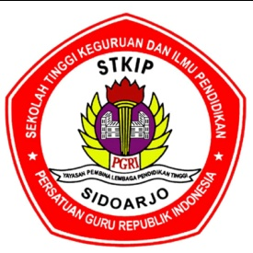
SEKOLAH TINGGI KEGURUAN DAN ILMU PENDIDIKAN
STKIP PGRI SIDOARJO
TERAKREDITASI
Alamat: Jl. Jenggala, Kotak Pos 149, Kemiri, Sidoarjo Telp. 031-8950181/ Faks031-8071354
Website: http://www.stkippgri-sidoarjo.ac.id. Email: info@stkippgri-sidoarjo.ac.id.
- SUBJECT : Research Method  - CLASS : 2021C  - TIME ALLOCATION : 75 Minutes  - LECTURER : Dr. Lailatul Musyarofah, M.Pd.  - Type : Open book/ gadget | - NAME  - NIM

You are provided 10 research titles, you are required to analyze five titles to decide the possible research method/design, instruments, and data collection techniques.
No | Research Titles | Research Method/ Design | Instruments | Data Collection Techniques
1 | Increasing the Students Reading Comprehension Achievement through Questioning Technique
2 | The Influence of Student Vocabulary Mastery toward Writing narrative Text Ability
3 | The Analysis of Using Lexical Cohesion on the Abstract of Undergraduate Thesis
4 | Developing the Students Ability in Writing Recount Text Through Guiding Questions Technique
5 | Semantic Analysis on The Student’s Ability in Distinguishing Ambiguity and Anomaly Sentence of English among the Students of the Fifth Semester
6 | Using Suggestopedia Method in Teaching English for the Fifth Class Students
7 | The Implemention of Drama Techniques for Teaching Speaking Ability
8 | Implementation of Education Game base on Computer to Increase the Students' Learning Achievement at the Third Grade of SDN 2 Yukum Jaya
9 | Analysis of Students' Reading Purpose among the Third Semester Students of English Education Study program
10 | The Ifluence of Using Larson’ Model toward the Students’ Ability in Translating Textamong the Fifth Semester Students

